LSHS Varsity Girls Soccer 2021

DATE | LOCATION | OPPONENT | GAME TIME | BUS
 |  | red away/ black home | 1st time is varsity | r-return d-drop
4/14-WE | A | St. Clair | 6:00(4:30jv)
4/16-F | A | Fraser* | 6:00(4:30jv)
4/19-M | H | Stevenson* | 6:00(4:30jv)
4/21-W | A | Chippewa Valley * | 7:00(5:15jv)
4/23-F | A | Utica* | 6:30(5:00jv)
4/26-M | A | Romeo* | 7:00(5:15jv)
4/28-W | A | LCN* | 6:30(4:30jv)
4/30-F | H | Lakeview | 6:00(4:30jv)
5/3-M | A | South Lake | 5:00
5/5-W | H | Fraser* | 6:00(4:30jv)
5/7-F | A | Clawson | 5:30
5/10-M | A | Stevenson* | 6:30(5:00jv)
5/14-F | H | Chippewa Valley* | 6:00(4:30jv)
5/17-M | H | Utica* | 6:00(4:30jv)
5/19-W | H | Romeo* | 6:00(4:30jv)
5/21- F | H | GPS(senior night) | 6:00(4:30jv)
5/24-M | H | LCN* | 6:00(4:30jv)
 |  | DISTRICTS@LSHS
 |  | 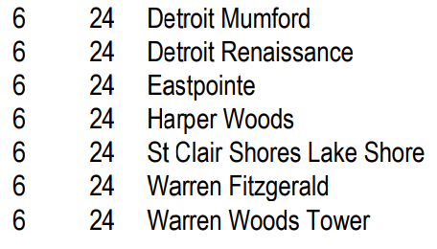
Contact- Coach Lount via email at dlount@lsps.org
Coach Gwozdz at cgwozdz@lsps.org

Open dates 3/24, 3/29, 3/31 , 5/3, 5/12

